Procurement of TiH₂ – Readily Available?
Taesuk Oh

According to publicly available literature, titanium hydride (TiH₂) is utilized as a mandatory intermediate phase in titanium powder production via the hydride–dehydride (HDH) process. In this process, titanium metal is first hydrogenated to form TiH₂, which is subsequently crushed and dehydrogenated to produce titanium powder. As a result, the formation and decomposition of TiH₂ are intrinsic steps in HDH-based titanium powder manufacturing.
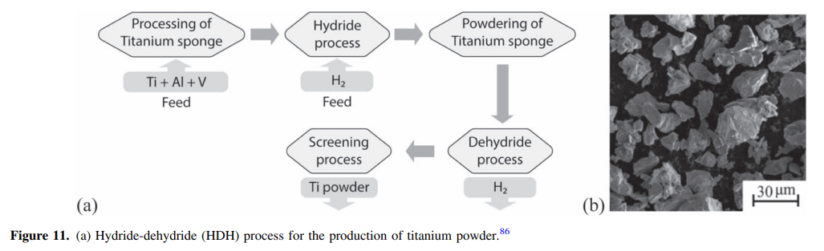
(Retrieved from: Ramma G. Reddy, et al., “Review—The Emerging Technologies for Producing Low-Cost Titanium” Journal of The Electrochemical Society, 2021 168 042502)
In a technical report published by the Pacific Northwest National Laboratory (PNNL), the commercialization roadmap of ADMA Products explicitly states that “THE PLANT WILL PRODUCE 1500 METRIC TONS (3.3 million lbs.) OF ADMA HYDROGENATED TITANIUM POWDER PER YEAR” [1]. This publicly documented production target demonstrates that processes involving hydrogenated titanium powders, i.e., TiH₂-related materials, are designed to operate at an industrial scale of well above several hundred metric tons per year.
Furthermore, a review paper by Froes reports that “By 2013 hydride de-hydride (HDH) shipments had increased steadily to 1,750 tpa,” indicating that the global shipment volume of HDH titanium powder had already reached approximately 1,750 metric tons per year by 2013 [2]. Since the HDH process inherently includes TiH₂ formation and subsequent dehydrogenation, this shipment volume provides indirect evidence that TiH₂ has been handled at the scale of several hundred to thousand tons per year within the existing industrial supply chain.

In addition, OSAKA Titanium Technologies explicitly states on its official product information page that “We produce hydride-dehydride processed titanium powder and titanium hydride powder,” confirming that titanium hydride powder is produced and supplied as part of its commercial powder product portfolio [3]. This further indicates that TiH₂ is not limited to localized or laboratory-scale use, but is available through an established industrial supply chain in allied countries.
Taken together, these publicly available sources indicate that an annual TiH₂ supply on the order of 1,000 metric tons can be met within the scale of existing HDH-based titanium powder production and commercialization activities, and therefore does not represent an unusually demanding or unrealistic supply requirement.
References
[1] Pacific Northwest National Laboratory (PNNL),
Low-Cost Titanium Powder for Defense and Commercial Applications,
PNNL-19932, 2011.
https://www.pnnl.gov/main/publications/external/technical_reports/PNNL-19932.pdf
[2] F. H. Froes,
Future prospects for titanium powder metallurgy markets,
Key Engineering Materials, Vol. 704, 2016.
https://www.scientific.net/KEM.704.271
[3] OSAKA Titanium Technologies Co., Ltd.,
Powder products / Development materials (official product information).
https://www.osaka-ti.co.jp/e/e_product/development/hunmatu.html

Commercial Uses of Titanium Hydride (TiH₂)
Titanium hydride (TiH₂) is commercially used primarily as an industrial intermediate and processing aid in titanium powder and powder-based manufacturing routes. Its major commercial uses are summarized below.
- HDH titanium powder production (largest use)
TiH₂ is an essential intermediate in the hydride–dehydride (HDH) process for producing titanium metal powder. Titanium metal is first hydrogenated to form brittle TiH₂, which is easily crushed and milled, and then dehydrogenated to obtain titanium powder. This route supplies titanium powders for powder metallurgy (PM), metal injection molding (MIM), and cost-sensitive additive manufacturing processes.
- Powder metallurgy and sintering aid
TiH₂ is directly added to powder metallurgy systems as a hydrogen source. Controlled hydrogen release during heating can enhance sintering behavior, assist densification, and influence microstructural evolution in titanium and titanium-alloy compacts.
- Deoxidizing and reducing agent in metallurgy
TiH₂ is used as a deoxidizer or reducing additive in metallurgical processing, where hydrogen evolution and titanium’s chemical affinity for oxygen are exploited to control oxygen content in metal systems.
- Pyrotechnic and energetic materials (specialty use)
Due to its high reactivity and hydrogen content, TiH₂ is used in pyrotechnic formulations, ignition systems, and specialized energetic applications. Although smaller in volume, this is a well-established commercial niche.
- Research and specialty materials applications
TiH₂ is also supplied for laboratory, nuclear, and advanced materials research, including hydrogen-related materials studies and specialty powder processing routes.

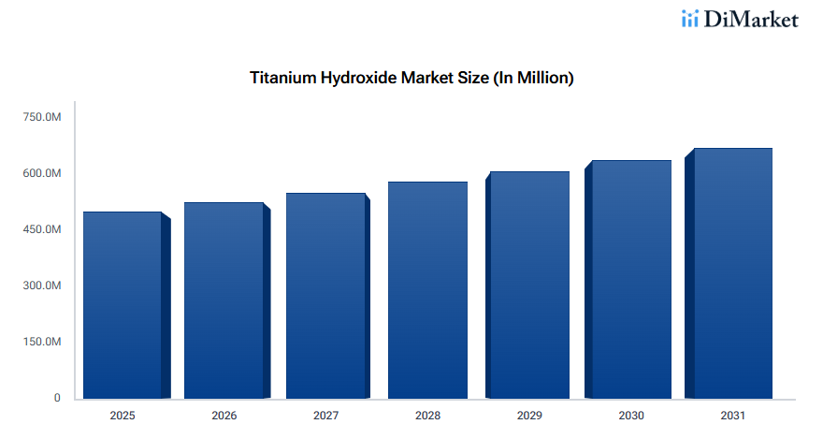
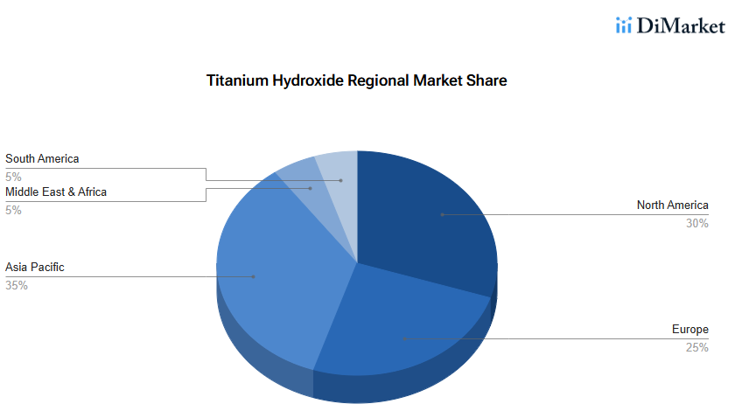
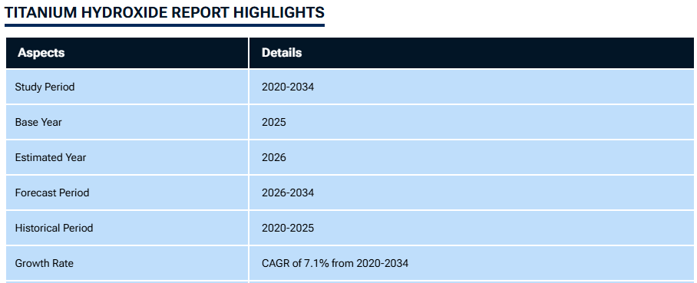
(https://www.datainsightsmarket.com/reports/titanium-hydroxide-1839303?tab=toc)

